HOW TO CREATE An AWS ACCOUNT

CLICK THE LINK BELOW TO CREATE A ACCOUNT

<https://portal.aws.amazon.com/billing/signup?refid=09863622-0e2a-4080-9bba-12d378e294ba&redirect_url=https%3A%2F%2Faws.amazon.com%2Fregistration-confirmation#/start/email>

STEP 1: **Enter the Email id and account name**  
  
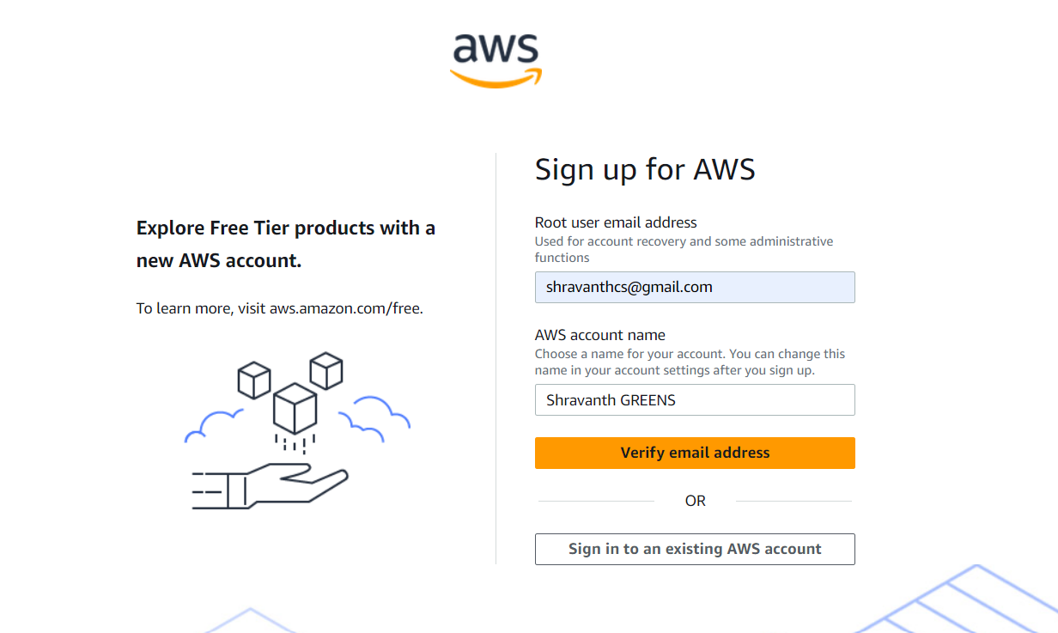

STEP2: **Check your email for verification code**   
  
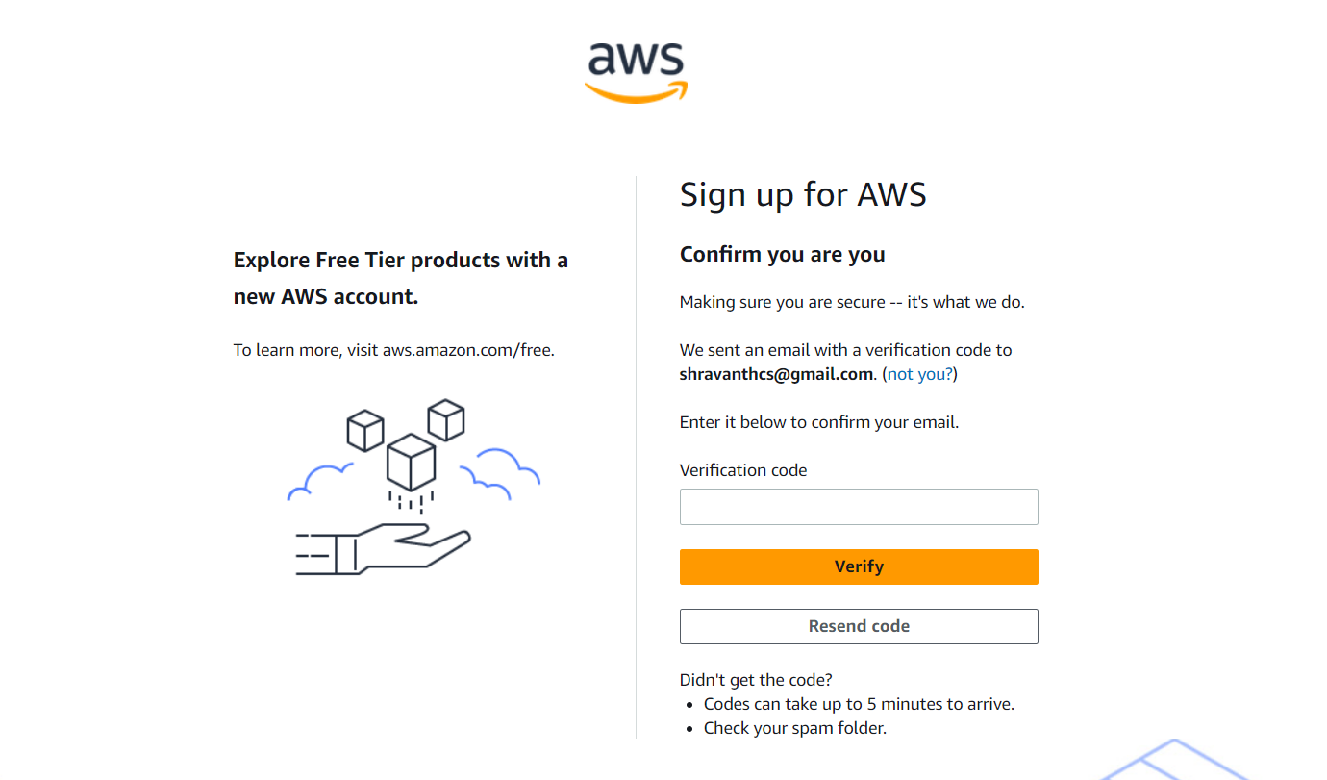

STEP 3: **Enter full name and personal details showing below**  
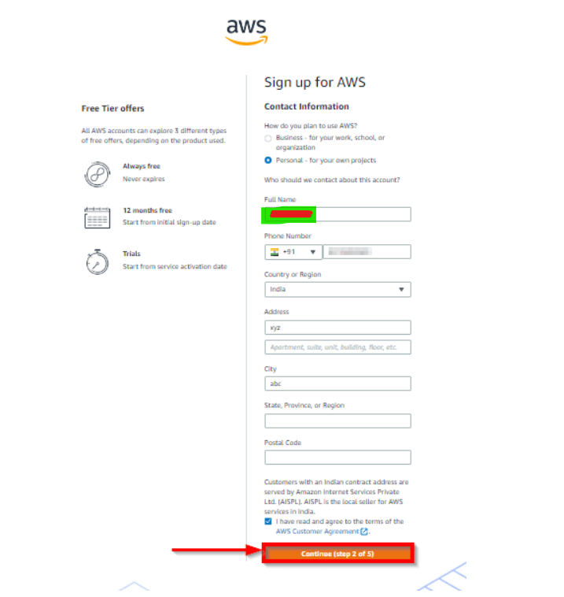

Step4: **Enter your CARD information**  
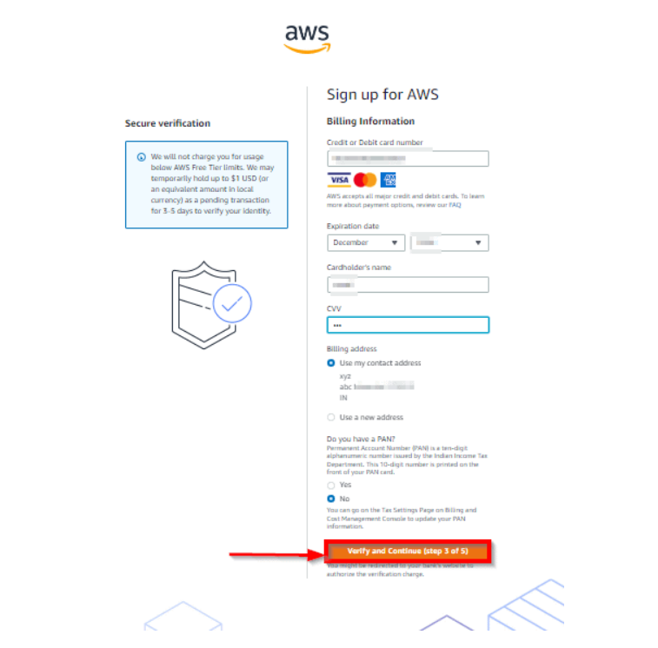

Step5: **Verify the OTP**

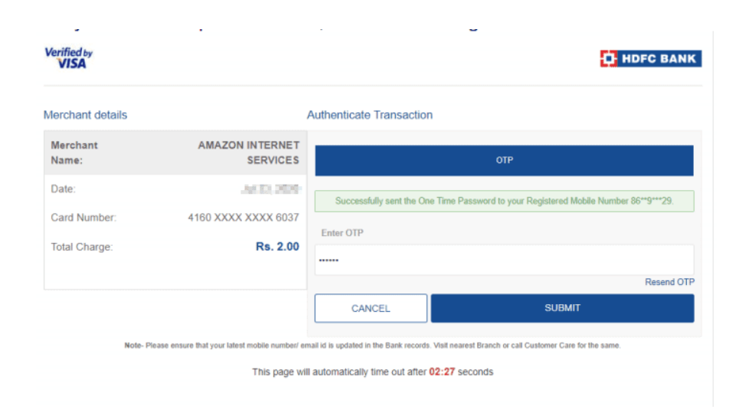

Step 6: **Confirm your Mobile Number**

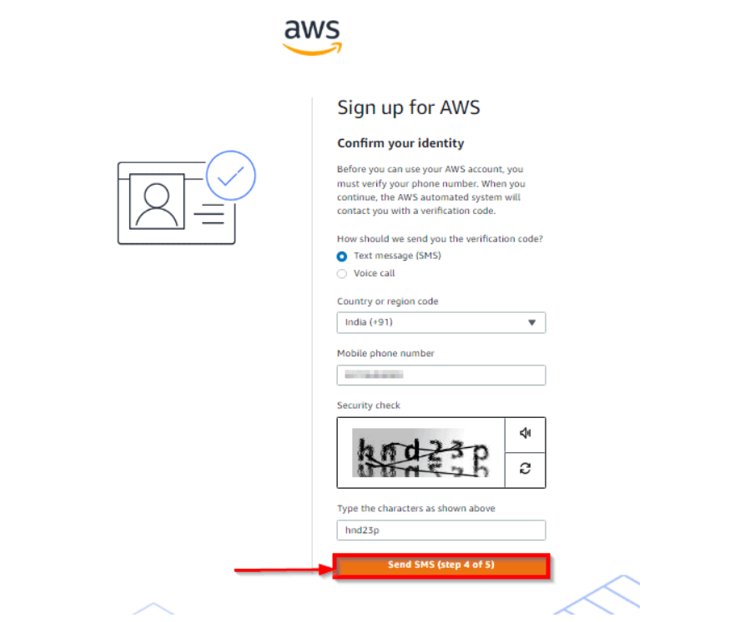

Step 7:

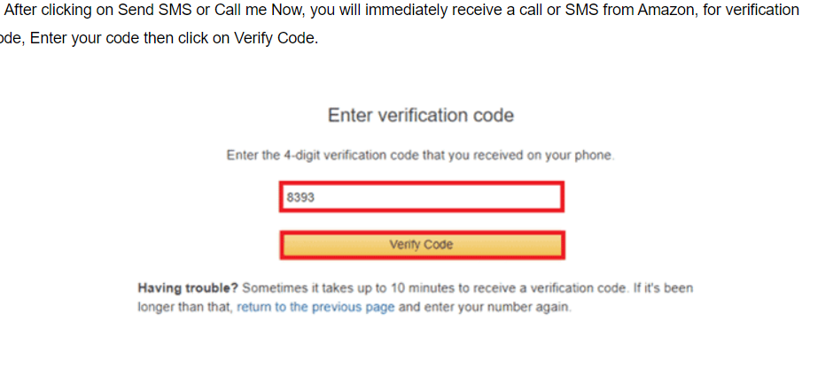

Step 8: **SELECT THE PLAN**

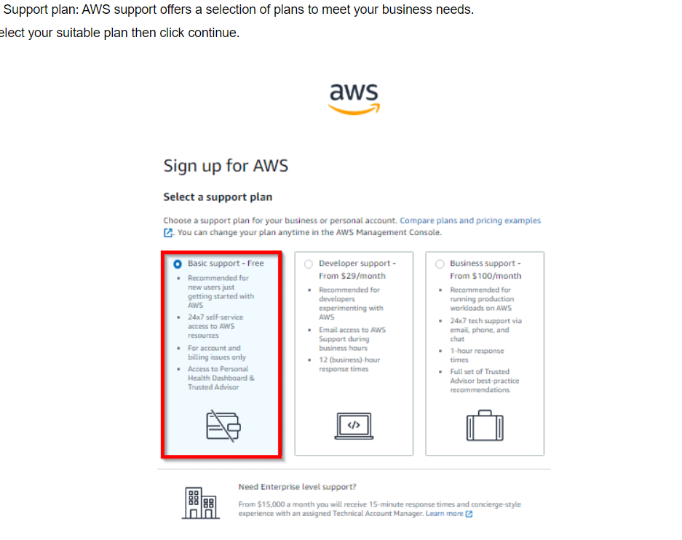

**START USING THE CONOSLE with the given EMAIL ID and PASSWORD**